Assignment 1

uname, pwd, hostname, data, cal



ls,dir

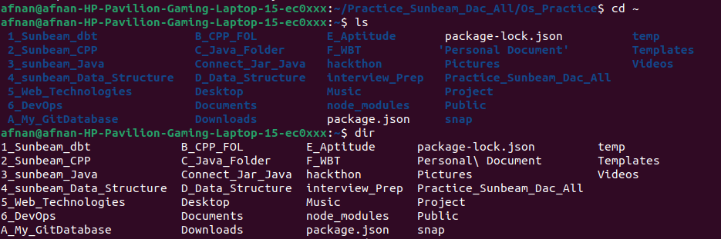

cat, cat>>

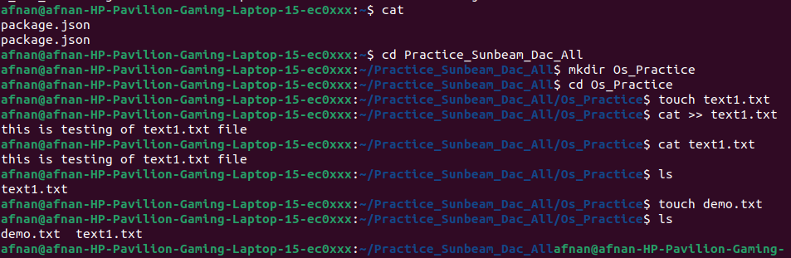
cp

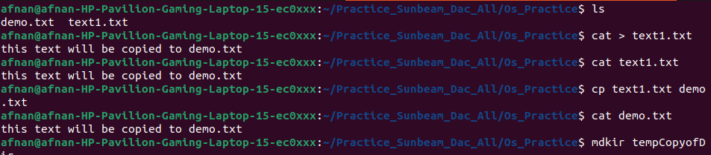
mv

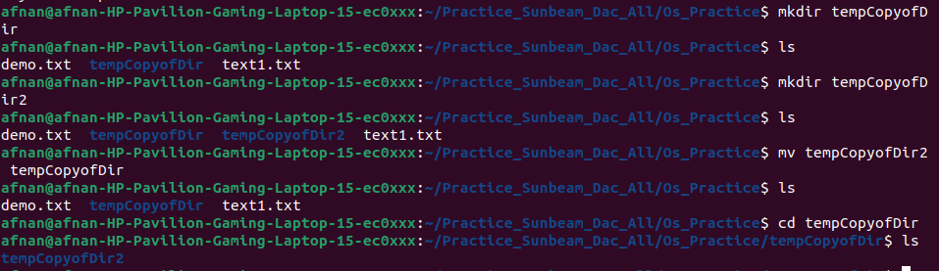
tac

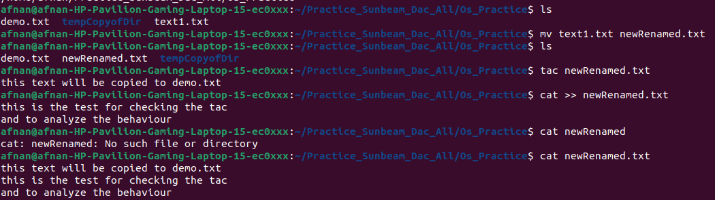
tac, rev,wc

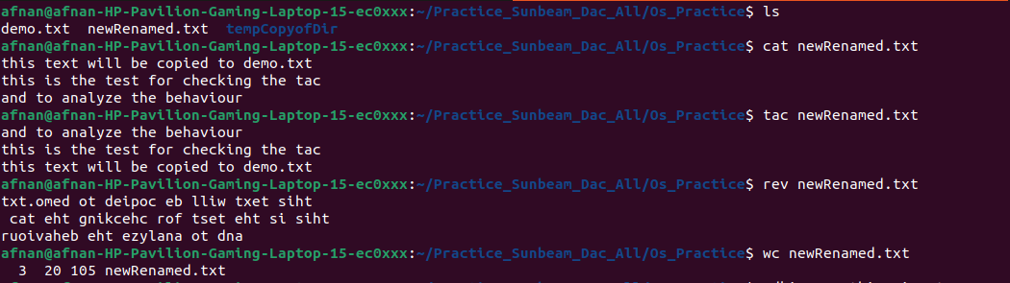

mkdir, cd, rm

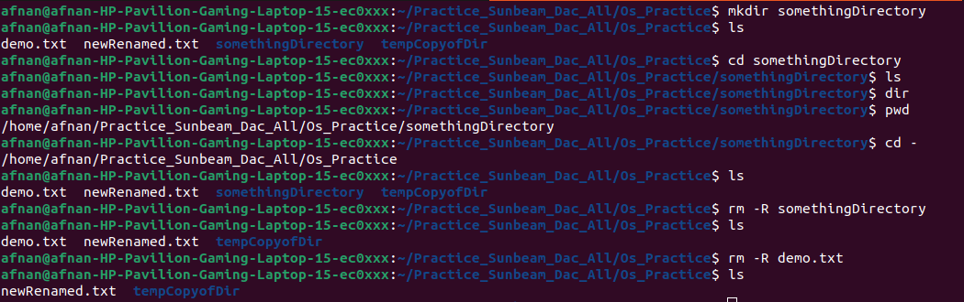

rmdir, touch

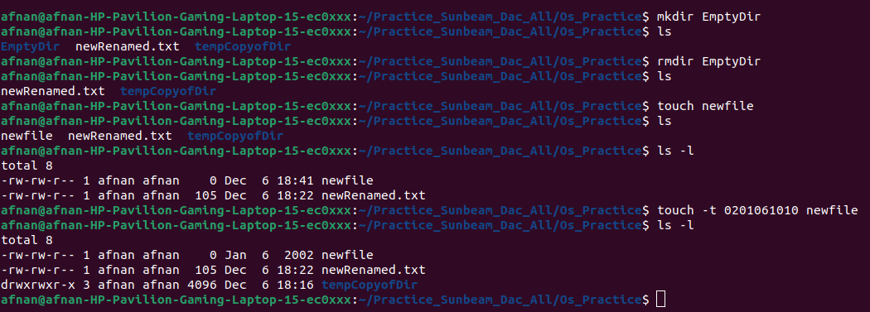
touch

sort, uniq

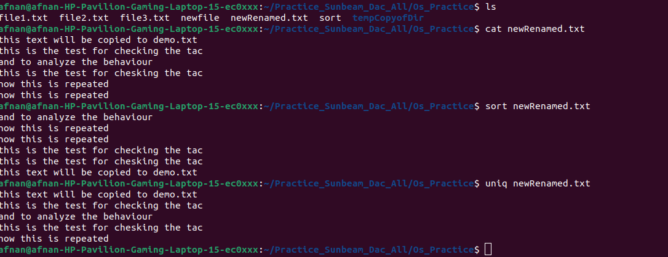

head

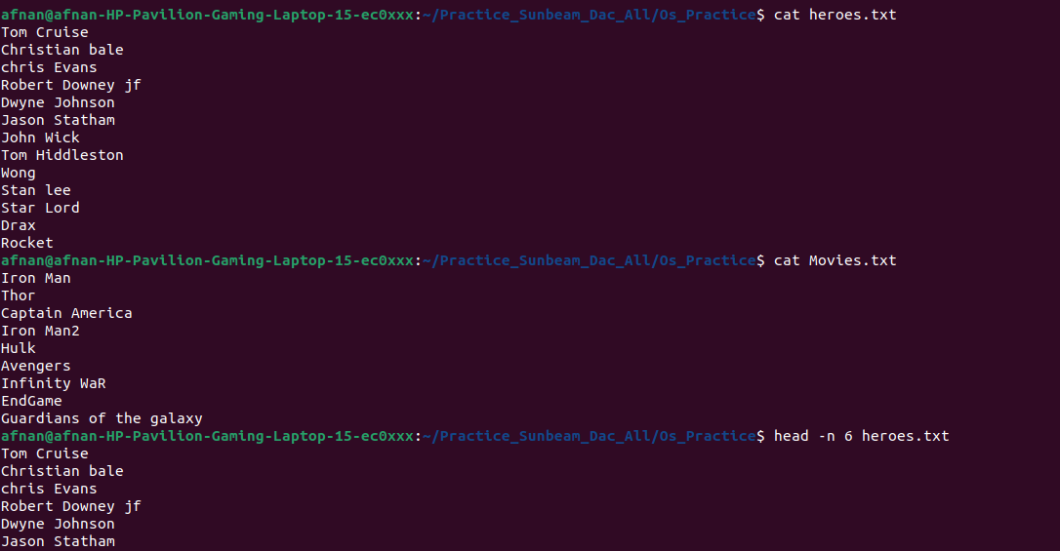

tail

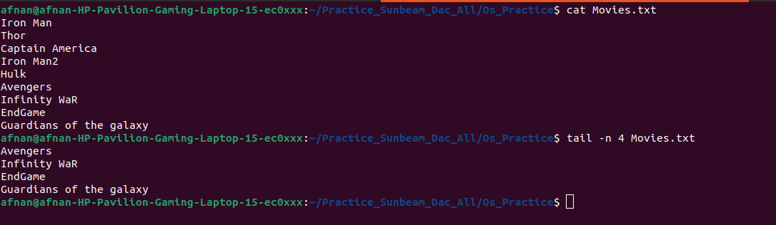

factor

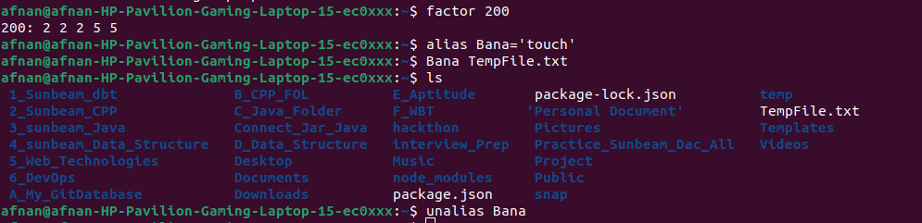

echo

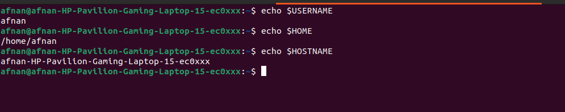

ps

kill

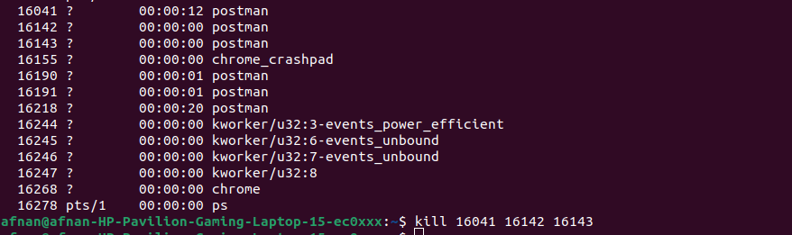

env

